Jean Baptiste Poquelin Molière: Lakomec
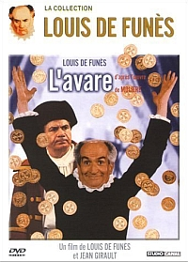 L'avare (1980)
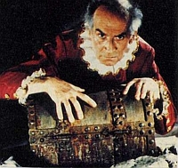 Harpagon – Louis de Funès
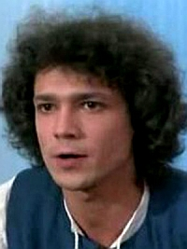 Kleant (Harpagonov syn, Mariannin milý) – Franck Cabot-David
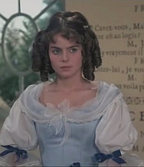 Marianna (Kleantova milá, Harpagonova vyvolená) – Anne Caudry
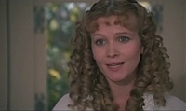 Eliza (Harpagonova dcéra, Valérova milá) – Claire Dupray
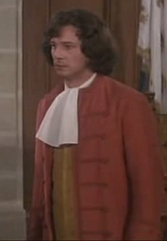 Valér (Anzelmov syn, Elizin milý) – Hervé Bellon
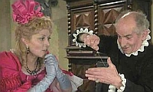 Frozina (dohadzovačka) – Claude Gensac
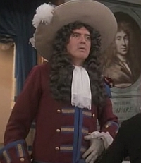 Anzelm (Valérov a Mariannin otec) – Georges Audoubert
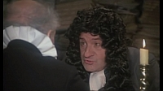 Majster Šimon (sprostredkovateľ, notár) – Max Montavon
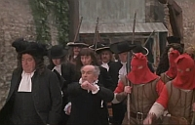 policajný komisár – Henri Génès
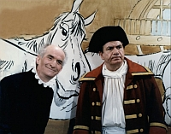 Jacques (Harpagonov sluha a kočiš) – Michel Galabru
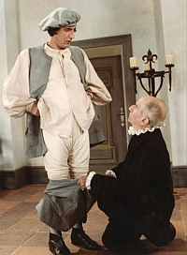 La Flèche (Kleantov sluha) – Bernard Menez
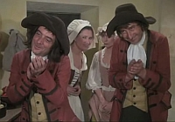 sluhovia a slúžky

Poznámky

- komédia napísaná v próze: ....................................................................................................................

................................................................................................................................................................

- vlastnosti frašky: ....................................................................................................................................

................................................................................................................................................................

................................................................................................................................................................

................................................................................................................................................................

- vlastnosti komédie omylov: ..................................................................................................................

................................................................................................................................................................

................................................................................................................................................................

................................................................................................................................................................

- stopy po komédii dell'arte: ...................................................................................................................

................................................................................................................................................................

................................................................................................................................................................

................................................................................................................................................................

- filmové postupy v sledovanej francúzskej inscenácii: ...........................................................................

................................................................................................................................................................

................................................................................................................................................................

................................................................................................................................................................

